# CS 255 System Design Document Scranton

## UML Diagrams

### UML Use Case Diagram

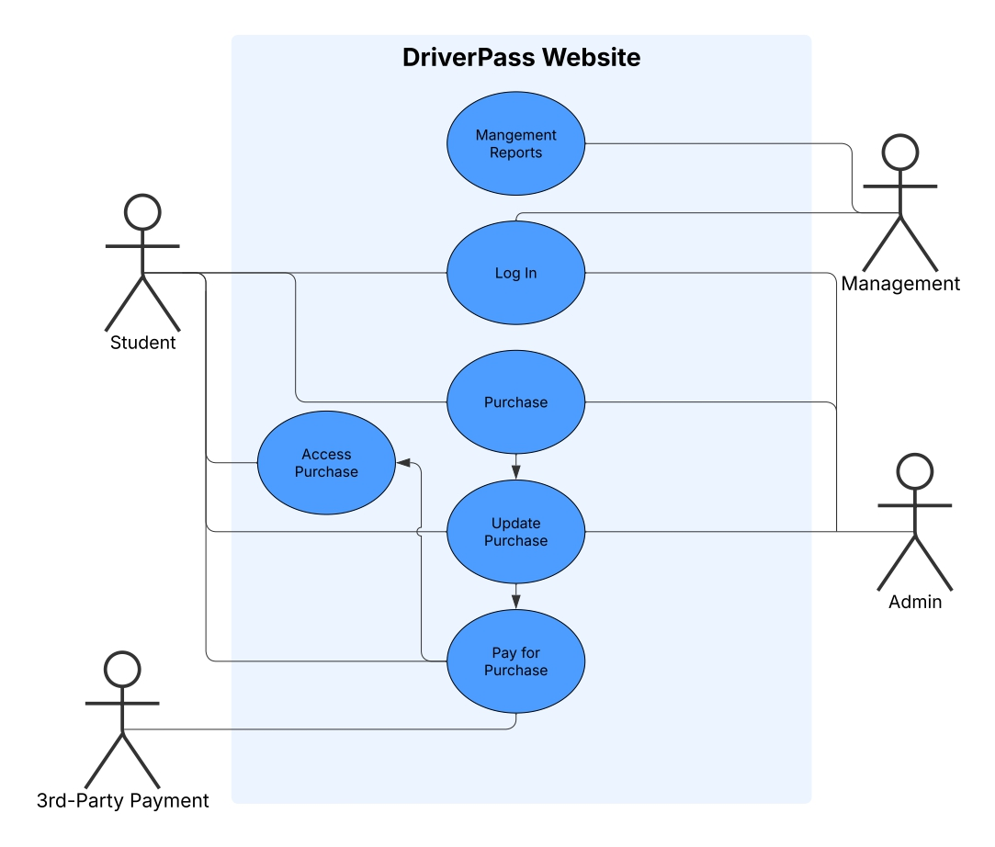

### UML Activity Diagrams

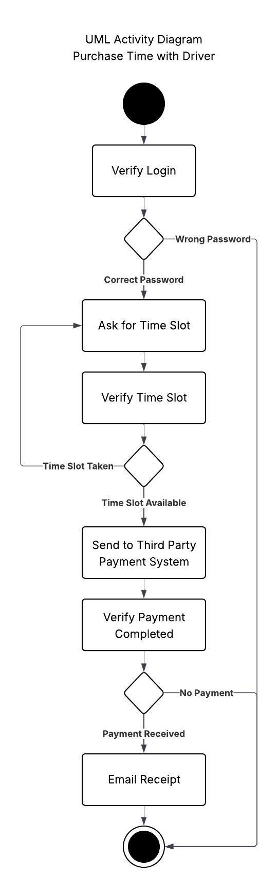

### UML Sequence Diagram

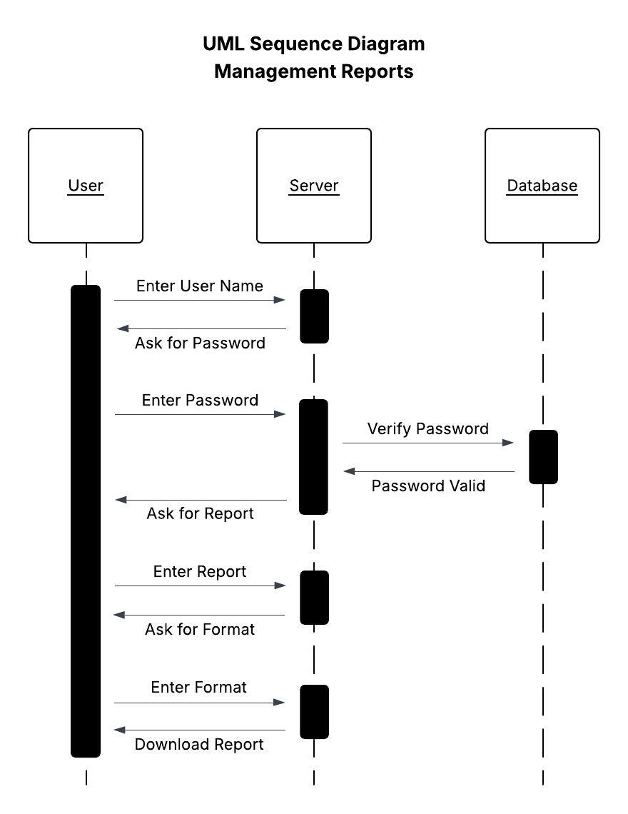

### UML Class Diagram

## Technical Requirements

* Database and backend cloud servers for website
* Secure login servers
* Various permission profiles assigned to logins to allow access to different parts of the website
* Video streaming software which will not slow down servers
* Connection to third-party payment system
* Ability to generate reports in excel or pdf